Environment Setup Create a Flask Project

|  |  |
| --- | --- |
| Team ID | PNT2022TMID43211 |
| Project Name | Nutrition Assistant Application |

**Code :**

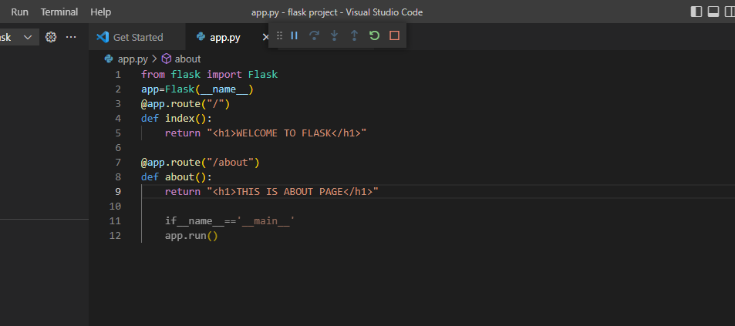

**Terminal :**

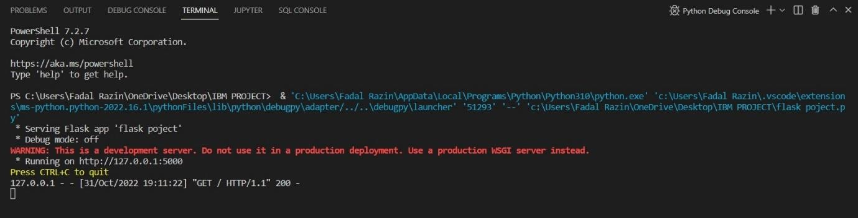

HOME page:

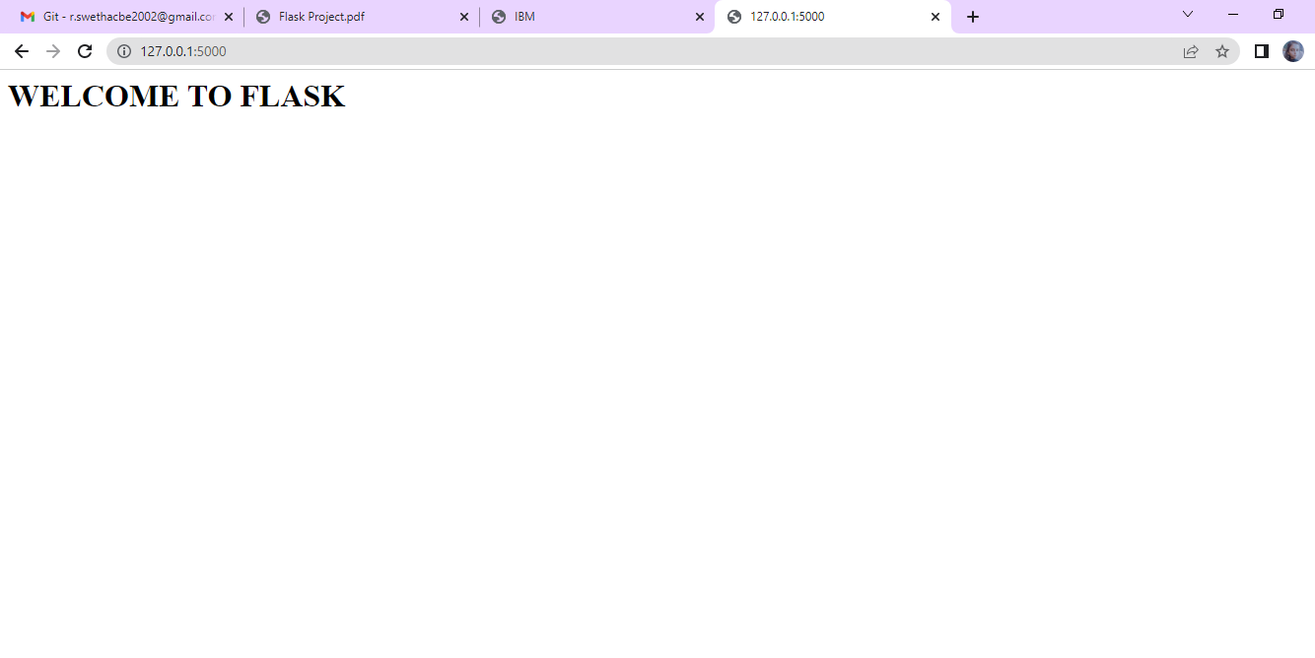

**ABOUT page:**

